Slide-1
1.Define Digital image processing. Why digital image processing?
Ans:
Digital Image Processing (DIP) is the use of computer algorithms to perform operations on digital images — to improve their quality, extract useful information, or prepare them for further analysis.
In simple terms: you take an image (which is just a matrix of numbers/pixels), and you apply mathematical operations on those numbers to get a better or more useful image.

Digital Image Processing (DIP) is needed because the human eye has limitations — we cannot see all types of information hidden in an image. Computers can process images mathematically and extract useful details that are invisible to the naked eye.
Here are the key reasons why DIP is important:
• Image Enhancement: To improve the visual quality of a poor or noisy image (e.g., medical X-rays or satellite photos).
• Feature Extraction: To detect edges, shapes, patterns, and objects inside an image automatically.
• Medical Imaging: Used in MRI, CT scans, and X-rays to help doctors detect diseases accurately.
• Security & Surveillance: Face recognition, fingerprint detection, and CCTV monitoring depend on DIP.
• Automation & Robotics: Machines use processed images to make smart decisions without human help.
In short, DIP helps us process, analyze, and understand images efficiently using computers — making it essential in almost every modern technology field.

2.what is digital image?
Ans:
A digital image is a 2D array (matrix) of pixels (picture elements), where each pixel holds a numerical value representing the brightness or color at that specific location. It is a digital representation of a real-world scene stored in computer memory.
Key concepts:
• A digital image is represented as f(x, y), where x and y are the spatial coordinates, and f is the intensity/brightness value at that point.
• For a grayscale image, each pixel has a single value from 0 (black) to 255 (white).
• For a color image (RGB), each pixel has 3 values — one for Red, one for Green, and one for Blue.

Example: A 4×4 grayscale image looks like this in memory:
[ 10 50 80 100 ]
[ 20 60 90 120 ]
[ 30 70 100 150 ]
[ 40 80 110 200 ]
Each number is the brightness of one pixel. Larger value = brighter pixel. DIP processes these numbers mathematically to enhance or analyze the image.

3.what is pixel?
Ans: A pixel is the smallest unit of a digital image. It represents a single point of the image. Each pixel has a location (x,y) and an intensity value.

4.The fundamental steps in digital image processing ( explain + board question )
Ans:
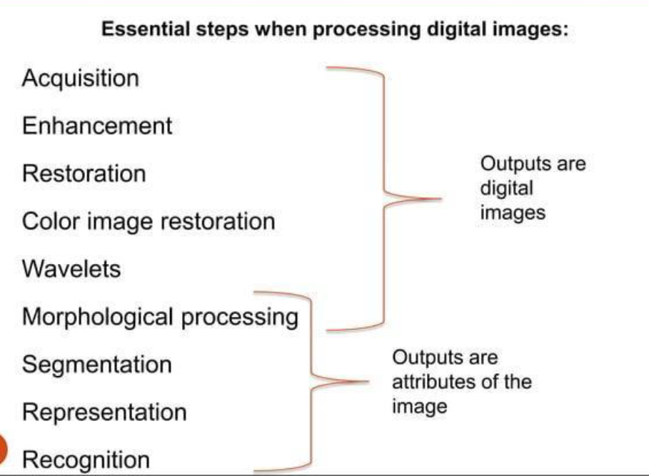

5.Maths at the end of the slide.
You have an image 200x200. How much memory is required to store in
- Black/white.
- Grayscale with 30 gray levels.
- Color image with 6 bits quantization.
Ans:
i.black/white:
given: image size = 200 x 200
total pixels = 200 x 200 = 40,000
black and white image have only 2 levels => 1 bit per pixel
memory = 40,000 x 1 = 40000 bits
convert to bytes : 40000 / 8 = 5000 bytes = 4.88 KB

ii.Grayscale with 30 level
Number of bits needed :
Log2(30)= 4.91 => 5 bits per pixel
Memory = 40000 x 5 = 200,000 bits
Convert to bytes: 200,000 / 8 = 25,000 bytes = 24.4 KB

iii.Color image with 6-bit quantization
Assuming total 6 bits per pixel :
Memory = 40,000 x 6 = 240,000 bits
Convert to bytes: 240,000 / 8 = 30,000 bytes = 29.3 KB

Slide-2
6.what is image enhancement?
Ans: Image enhancement is the process of improving the visual appearance of an image or making it more useful for further analysis. It does NOT add new information — it just makes the existing information clearer and easier to see or process.
The goal is to bring out hidden details, reduce noise, increase contrast, and make the image look sharper or cleaner.
Types of/Domain of Image Enhancement:
A) Spatial Domain Methods (Direct operation on image / work directly on pixels):
• Intensity Transformation — Operates on single pixel
• Spatial Filtering — Operates in neighborhood
B) Frequency Domain Methods (work on frequency components):
7.what is thresholding? Explain the necessary diagrams( board question )
Ans:

8.define Brightness, contrast, sharpness.
Ans:
1. Brightness:
Brightness refers to the overall lightness or darkness of an image. It is controlled by the average pixel intensity value across the image. Increasing brightness adds a constant value to all pixels, making the image appear lighter. Decreasing brightness subtracts from all pixels, making it darker.
g(x,y) = f(x,y) + c (where c is the brightness constant)
Low Brightness Normal High Brightness
┌──────────┐ ┌──────────┐ ┌──────────┐
│ Very Dark│ │ Normal │ │Very Light│
└──────────┘ └──────────┘ └──────────┘
c < 0 c = 0 c > 0

2. Contrast:
Contrast makes an object distinguishable. It is the separation between the darkest and brightest area of the image. Increase contrast and you increase the separation between dark and bright, making shadows darker and highlights brighter.
Contrast = Max Pixel Value − Min Pixel Value
Low Contrast High Contrast
┌──────────┐ ┌──────────┐
│ Gray/Flat│ │Bright vs │
│ image │ │ Dark │
└──────────┘ └──────────┘
(narrow range) (wide range)

3. Sharpness:
Sharpness refers to the clarity of edges and fine details in an image. Sharpness can be defined as edge contrast, that is the contrast along edges in a photo. When we increase sharpness, we increase the contrast along/near edges in the photo while leaving smooth areas of the image along.
Blurry Image Sharp Image
┌──────────┐ ┌──────────┐
│ Soft │ │ Crisp │
│ edges │ │ edges │
└──────────┘ └──────────┘
(low frequency) (high frequency detail)

9. Negative Transformation + math.
Ans:
Negative transformation (also called image complement) inverts the intensity of every pixel in the image. Dark regions become bright and bright regions become dark. This is useful for enhancing white details on dark backgrounds (e.g., medical X-rays).
g(x,y) = (L - 1) - f(x,y)
s = (L - 1) - r
Where L = number of gray levels (for 8-bit image, L = 256),
f(x,y) = original pixel value,
g(x,y) = output pixel value.

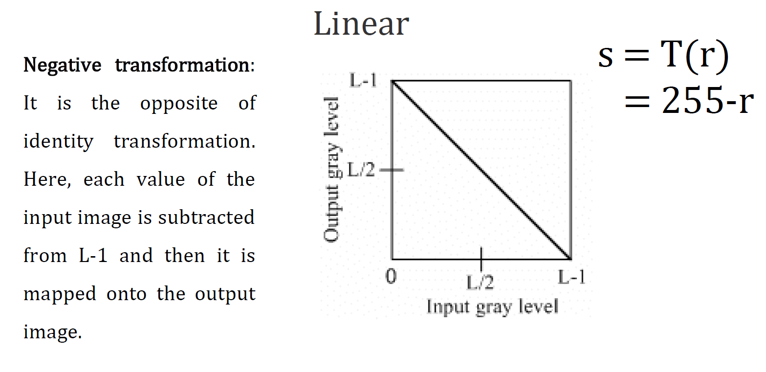
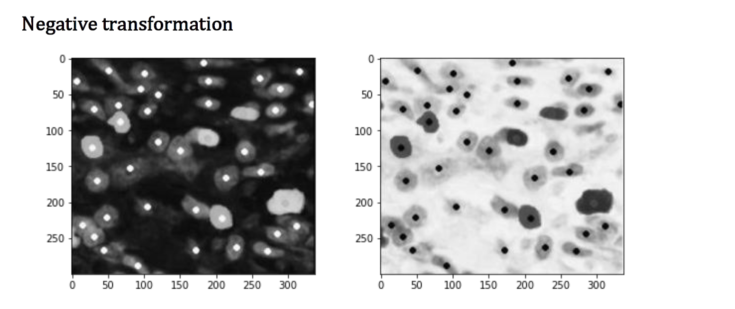

10.whats contrast stretching?
Ans:
Contrast stretching (also called normalization) is an image enhancement technique that increases the dynamic range of pixel intensities. Contrast stretching attempts to improve an image by stretching the range of intensity values it contains to make full use of possible values.
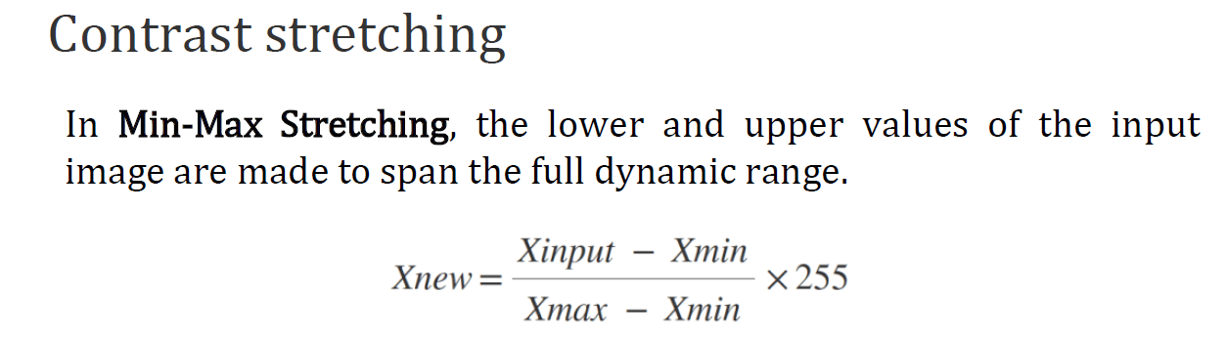
Visual Diagram:
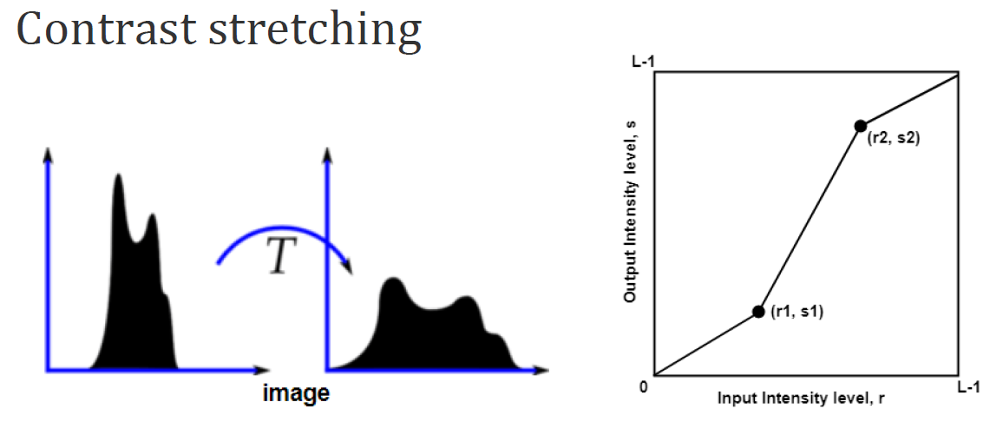
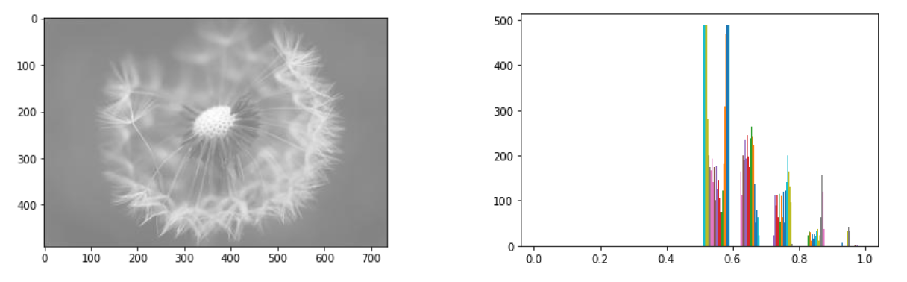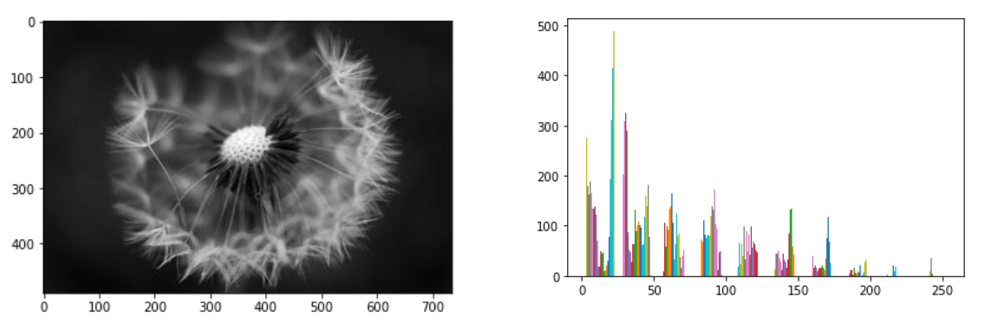

Contrast stretching is a point operation — it processes each pixel independently. It is widely used to improve the visibility of medical images, satellite images, and photos taken in poor lighting.
11.Explain bit plane slicing
Ans:
Bit plane slicing is a technique where a digital image is decomposed into 8 individual binary images, each representing one bit plane. Since each pixel in an 8-bit grayscale image is stored as an 8-bit binary number, we can separate these 8 bits into 8 different planes.
Each bit plane is a binary (0 or 1) image. The higher-order bit planes (Bit 7, Bit 6) contain the most important visual information, while the lower-order planes (Bit 0, Bit 1) contain fine detail and noise.

Example:
Say a pixel has intensity value 185. In binary: 185 = 10111001
Bit position: 7 6 5 4 3 2 1 0
Bit values: 1 0 1 1 1 0 0 1
↑ ↑
MSB (Most LSB (Least
Significant Bit) Significant Bit)

Bit Plane Diagram:
Original Image (8-bit): → Decomposed into 8 Bit Planes
┌────────────────────┐ Plane 7 (MSB): ██░░██░░ ← Most Important
│ Gray scale image │ Plane 6: ░░██░░██
│ pixel = 185 │ Plane 5: ██░░░░██
└────────────────────┘ Plane 4: ░░██░░░░
Plane 3: ██░░██░░
Plane 2: ░░░░░░░░
Plane 1: ░░░░░░░░
Plane 0 (LSB): ██░░░░██ ←Least Important

Applications:
• Image Compression: Lower bit planes can be removed to reduce storage with minimal quality loss.
• Steganography: Secret messages can be hidden in lower bit planes without visually affecting the image.
• Image Analysis: Higher bit planes show the structure; lower planes show the texture and noise.
In summary, higher bit planes (7, 6, 5) contain the dominant visual information, while lower bit planes (0, 1, 2) contribute to fine detail. This forms the basis of many compression and watermarking algorithms.

12.whats is histogram + histogram equalization math. For histogram equalization math show (input image histogram, calculation table, output image histogram)
Ans:
Histogram is a graphical representation of the intensity distribution of an image. It represents the number of pixels for each intensity value considered.
Histogram Equalization: It is a computer image processing technique used to improve contrast in images. It accomplishes this by effectively spreading out the most frequent intensity values, I e stretching out the intensity range of the image This method usually increases the global contrast of images when its usable data is represented by close contrast values. This allows for areas of lower local contrast to gain a higher contrast.
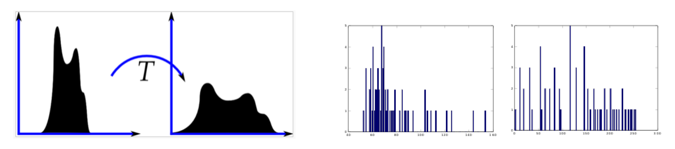
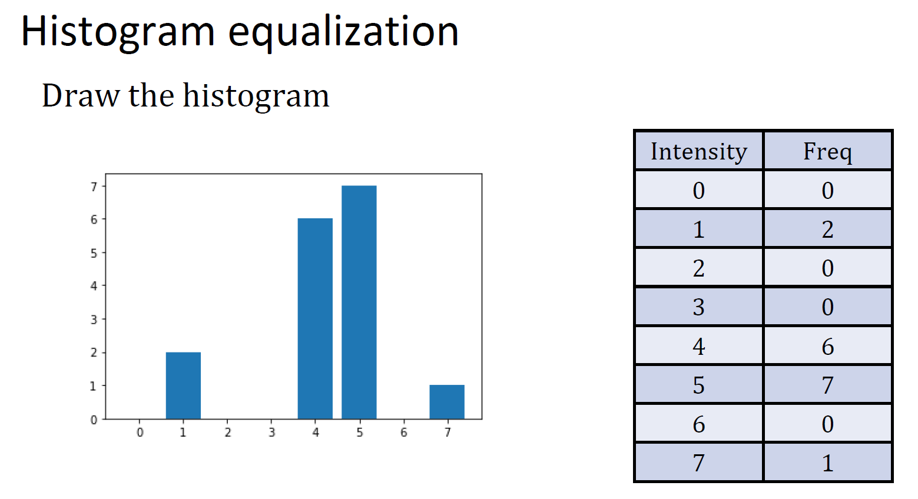
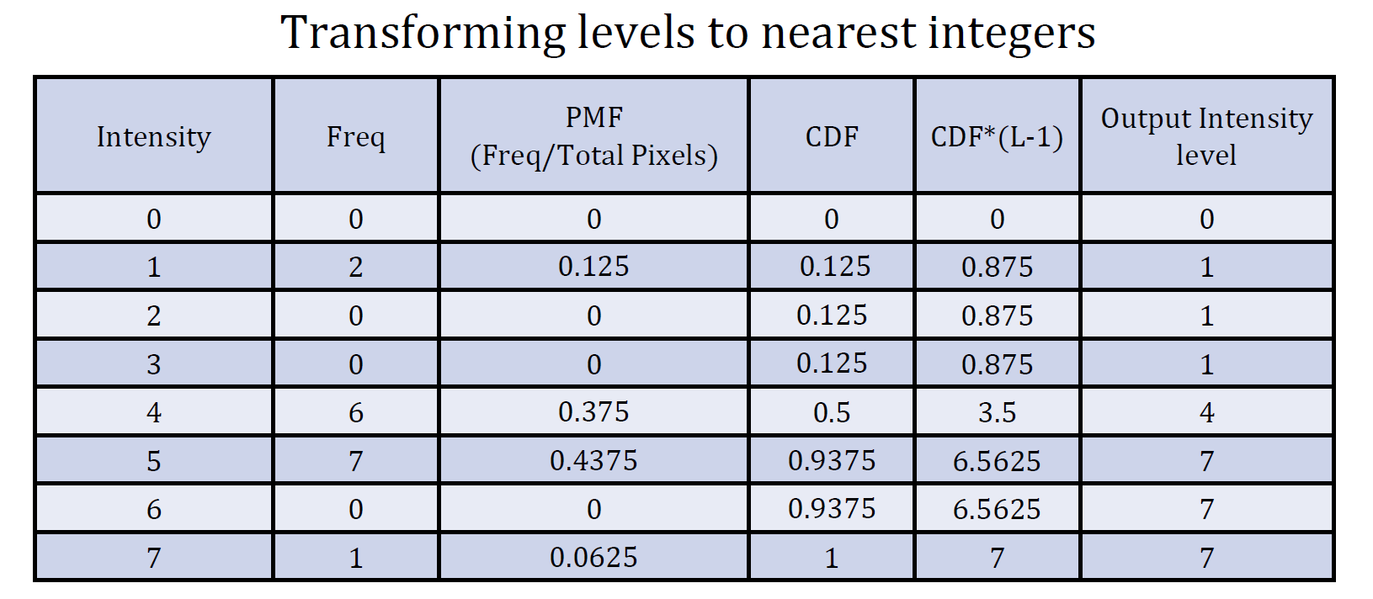
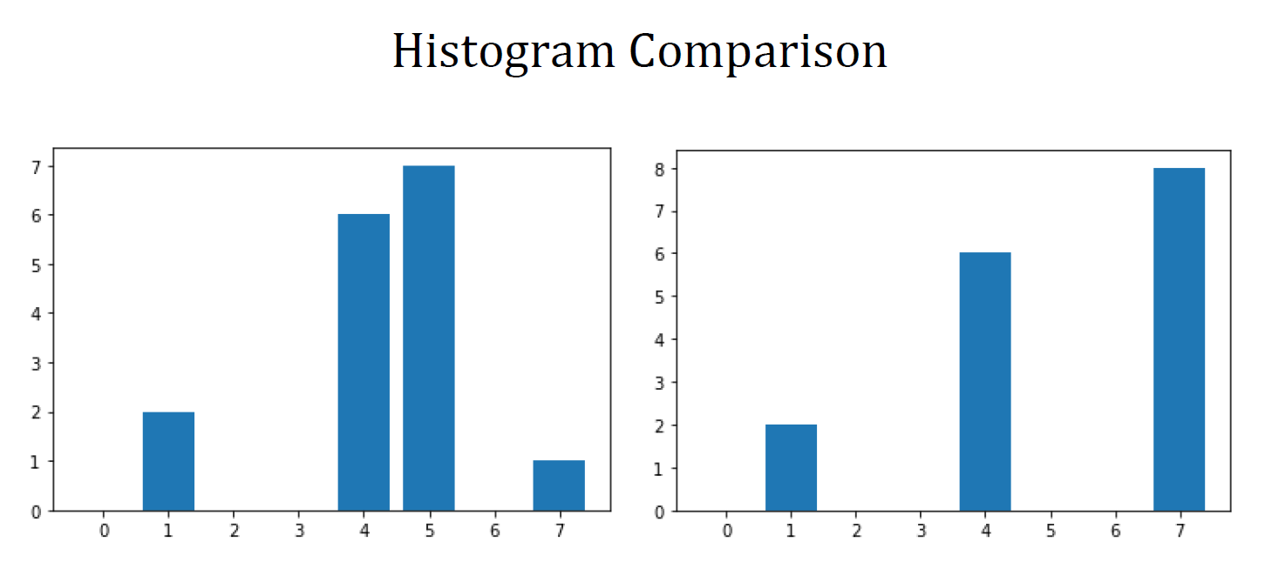
Histogram Equalization — Full Solved Example
1. What is Histogram Equalization?
Histogram Equalization is a technique used in digital image processing to improve the contrast of an image. When an image is too dark or too bright, its pixel intensities are concentrated in a small range. Histogram equalization redistributes those intensities across the full available range, making the image clearer and more detailed.

2. Key Terms
- Intensity (I) — the pixel brightness level (e.g., 0 to 7 for a 3-bit image)
- Frequency (Freq) — how many pixels have that intensity level
- Total Pixels (N) — sum of all frequencies
- L — total number of intensity levels (e.g., L = 8 means levels 0-7)
- PMF — Probability Mass Function; probability of each intensity
- CDF — Cumulative Distribution Function; running total of PMF values
- Output Intensity — the new intensity after equalization

Step 1 — Count frequencies (draw histogram)
Count how many pixels exist at each intensity level. Sum all frequencies to get total pixels N.

Step 2 — Calculate PMF
Divide each frequency by the total number of pixels:
PMF(I) = Freq(I) / N

Step 3 — Calculate CDF
Add up the PMF values cumulatively (each row = previous CDF + current PMF):
CDF(k) = CDF(k-1) + PMF(k)
Note: CDF always starts at 0 and ends at 1

Step 4 — Calculate Output Intensity
Multiply each CDF by (L - 1) and round to the nearest integer:
Output = round( CDF(k) x (L - 1) )
Note: In this example: L = 8 (intensities 0 to 7), so (L - 1) = 7

4. Worked Example
Given data: 8 intensity levels (0-7), Total pixels = 16
Intensity (I) | Freq | PMF (Freq / 16) | CDF (cumulative sum) | CDF × (L−1) = CDF × 7 | Output Intensity
0 | 0 | 0 | 0 | 0 | 0
1 | 2 | 2/16 = 0.125 | 0 + 0.125 = 0.125 | 0.875 | 1
2 | 0 | 0 | 0.125 + 0 = 0.125 | 0.875 | 1
3 | 0 | 0 | 0.125 + 0 = 0.125 | 0.875 | 1
4 | 6 | 6/16 = 0.375 | 0.125 + 0.375 = 0.5 | 3.5 | 4
5 | 7 | 7/16 = 0.4375 | 0.5 + 0.4375 = 0.9375 | 6.5625 | 7
6 | 0 | 0 | 0.9375 + 0 = 0.9375 | 6.5625 | 7
7 | 1 | 1/16 = 0.0625 | 0.9375 + 0.0625 = 1 | 7 | 7

5. Final Intensity Mapping
0 → 0 | 1 → 1 | 2 → 1 | 3 → 1 | 4 → 4 | 5 → 7 | 6 → 7 | 7 → 7

6. Output Histogram
8
6
4
2
0
Freq | 0 | 1 | 2 | 3 | 4 | 5 | 6 | 7
7. Intensity Mapping Matrix
In \ Out | 0 | 1 | 2 | 3 | 4 | 5 | 6 | 7
0 | 0
1 |  | 1
2 |  | 1
3 |  | 1
4 |  |  |  |  | 4
5 |  |  |  |  |  |  |  | 7
6 |  |  |  |  |  |  |  | 7
7 |  |  |  |  |  |  |  | 7

Table 5: Input-to-output mapping matrix (highlighted cell = output)

